Integrated Business Operations Platform (IBOP)
LY Project Guide-Dr. Anushree Deshmukh
External Company :- Shrinath Enterprises
Student:-Mann dutiya
rollno:-16010123192

Abstract
The Integrated Business Operations Platform (IBOP) is a web-based system designed to streamline and integrate key business functions such as sales and inventory management into a unified platform. Many small and medium enterprises rely on fragmented systems, leading to inefficiencies and poor data visibility.
This project focuses on developing a centralized solution that enables real-time data synchronization, automated calculations, and seamless interaction between modules. The system is built using modern frontend technologies and follows a modular architecture for scalability.
IBOP provides functionalities such as product management, sales tracking, automatic inventory updates, and validation mechanisms to ensure data consistency. The platform is designed for real-world deployment in a pharmaceutical distribution business, improving operational efficiency and decision-making.
Introduction
Many small and mid-scale businesses continue to rely on manual processes or disconnected software systems to manage core operations such as sales, accounting, HR, and inventory. This often leads to inefficiencies, data silos, and a higher likelihood of human error. In real-world business environments, the lack of integration further results in delayed decision-making and reduced operational visibility, making it difficult for businesses to respond quickly and effectively.
To address these challenges, the Integrated Business Operations Platform (IBOP) is being developed in collaboration with a real business, Shrinath Enterprises, ensuring practical relevance and real-world applicability. The system is designed as a centralized, real-time platform that integrates multiple business functions into a single interface, improving coordination and overall efficiency. By offering features such as live data tracking, role-based access, and streamlined workflows, IBOP enhances control over daily operations and supports more informed and timely decision-making.
Problem Statement
Businesses, especially small and medium enterprises, often rely on multiple disconnected systems to manage sales, inventory, finance, and human resources. This fragmentation leads to data inconsistencies, manual and inefficient workflows, and difficulty in obtaining real-time insights, ultimately affecting informed decision-making.
This project aims to develop an Integrated Business Operations Platform (IBOP) that consolidates key business functions such as CRM, sales, inventory, finance, and HR into a centralized web-based system. By integrating these operations into a single platform, the system enhances operational efficiency, reduces redundancies, and enables businesses to make faster and more accurate decisions.
Objectives
1. To design and develop a centralized platform that integrates multiple business
operations including sales, inventory, finance, and human resources.
2. To automate key workflows such as order processing, inventory updates,
invoicing, and reporting to reduce manual effort and errors.
3. To implement a role-based access system (Admin/User) for secure and
controlled data management.
4. To provide real-time data tracking and automated report generation for better
business insights and decision-making.
5. To build a scalable and customizable system that can adapt to different
business requirements.
Literature Review
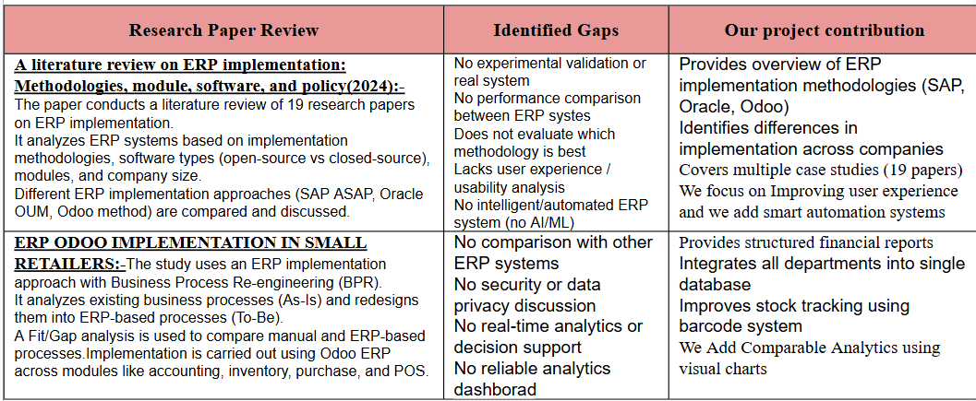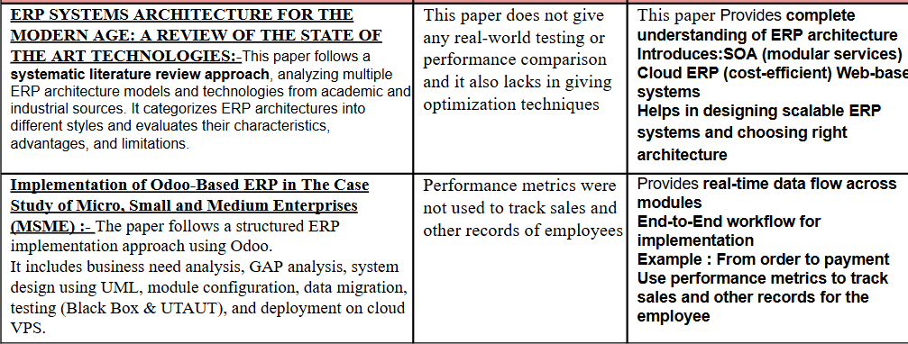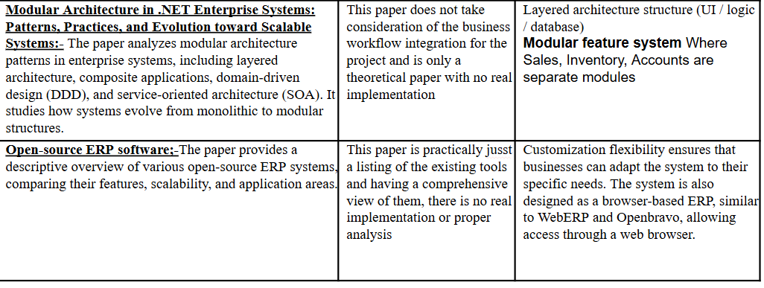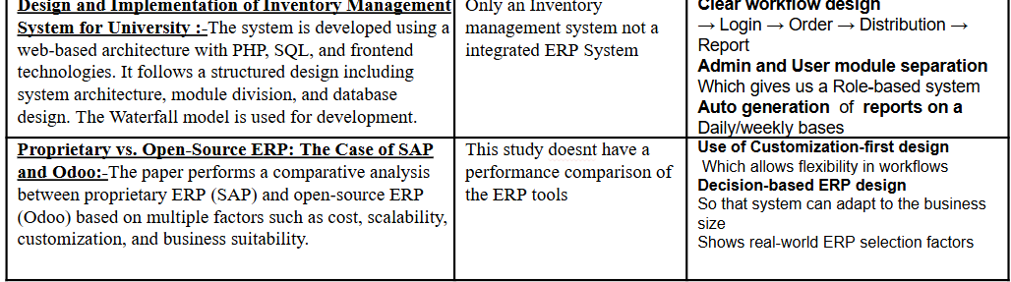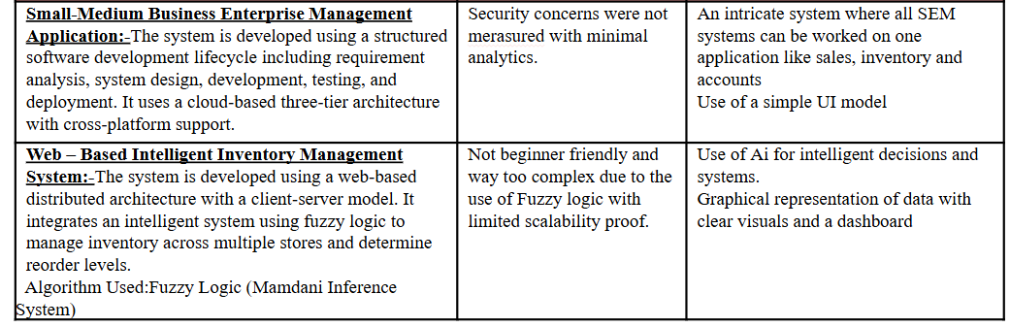
System Overview
The Integrated Business Operations Platform (IBOP) is a web-based application designed to centralize and streamline core business operations such as sales and inventory management. The system aims to replace fragmented and manual workflows with a unified digital platform that enables real-time data handling and improved operational efficiency.
The platform follows a modular structure, where each business function is implemented as an independent module. Currently, the system includes key modules such as Sales and Inventory, which are interconnected to ensure seamless data flow. For example, when a sale is recorded, the inventory is automatically updated, eliminating the need for manual stock adjustments.
IBOP is developed using modern frontend technologies and operates as a single-page application, ensuring smooth navigation and responsiveness. The system focuses on usability, allowing users to easily manage products, create sales records, and view updated data through a centralized dashboard.
Additionally, the platform is designed with scalability in mind. While the current implementation uses frontend-based state management, the architecture allows for future integration with backend services, enabling features such as persistent storage, multi-user access, and advanced analytics.

Architecture Design
The architecture of IBOP follows a modular and layered approach, separating the system into distinct components such as the frontend layer, state management layer, business logic layer, and future backend integration.
The frontend layer is developed using React and serves as the user interface of the system. It includes modules such as Dashboard, Sales, and Inventory, which allow users to interact with the system. Navigation between these modules is handled using a routing mechanism, ensuring a seamless user experience.
At the core of the system lies the state management layer, implemented using the React Context API. This layer acts as a centralized data store, managing key entities such as products and sales records. By maintaining a single source of truth, the system ensures that all modules have access to consistent and up-to-date information.
The business logic layer handles the core operations of the system. It is responsible for validating user inputs, performing calculations such as total and final sale amounts, and updating inventory levels based on sales transactions. This layer ensures data integrity and enforces rules such as preventing sales when sufficient stock is not available.
The architecture also includes provisions for future backend integration. A backend layer, using technologies such as Node.js and a database, can be connected to the system to enable persistent data storage, authentication, and multi-user support. This makes the system scalable and suitable for real-world deployment.
Overall, the architecture ensures clear separation of concerns, real-time data synchronization, and ease of scalability, making IBOP a robust and extensible business management solution.
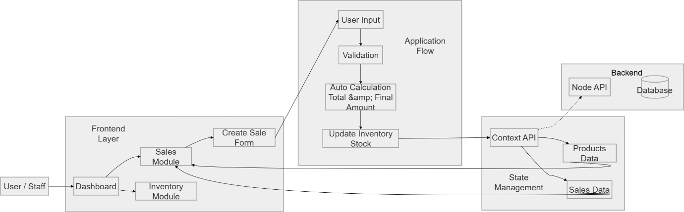
Implementation
The implementation of the Integrated Business Operations Platform (IBOP) focuses on developing a modular and interactive system that integrates sales and inventory operations within a unified interface. The system is built using React for the frontend, with Tailwind CSS for styling, and utilizes the Context API for centralized state management.

Data Management
The system uses the React Context API to manage and share data across different modules. A centralized context is implemented to store and manage key data entities such as products and sales records.
This approach ensures that all components have access to a single source of truth, enabling real-time synchronization between modules. Any updates made in one module, such as adding a product or recording a sale, are immediately reflected across the entire application.
The data is currently stored in the frontend state, allowing fast interaction and simplified development. The architecture is designed to support future integration with a backend database for persistent storage.

Inventory Module
The Inventory module is responsible for managing product-related data. It allows users to add new products by specifying attributes such as product name, price, and stock quantity.
All products are displayed in a structured tabular format, enabling users to easily view and manage inventory. The module serves as the foundation for other functionalities, as product data is used dynamically in the sales process.
The system maintains accurate stock levels, which are automatically updated whenever a sales transaction occurs.
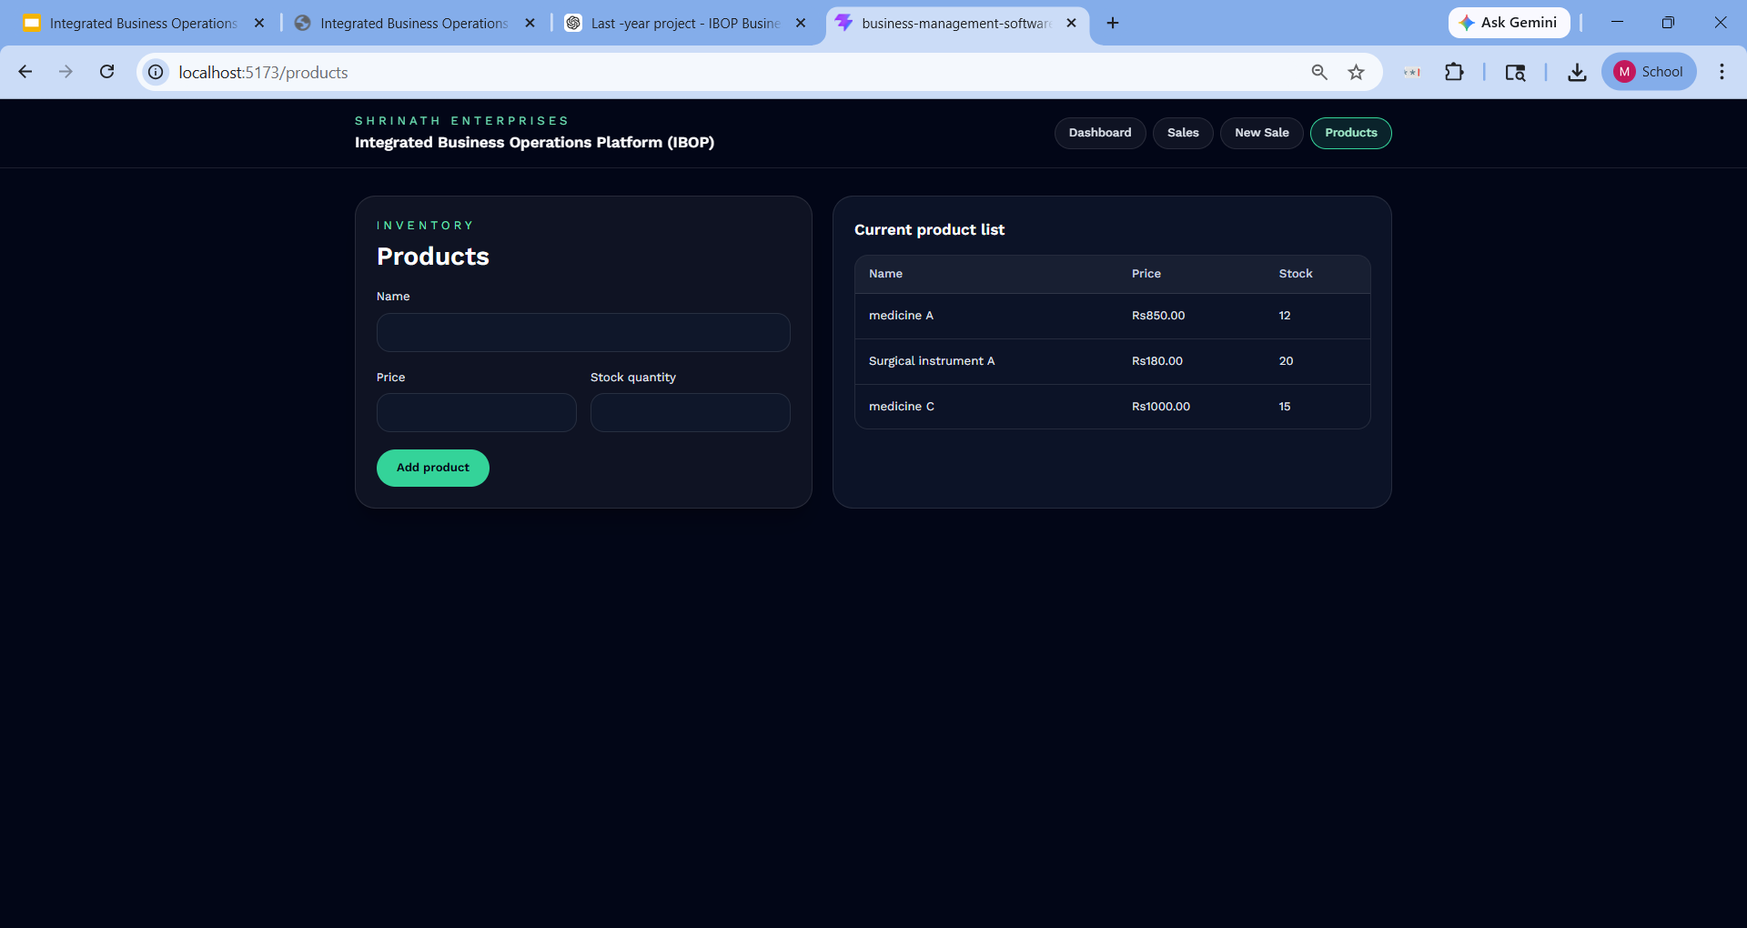

Sales Module
The Sales module enables users to create and manage sales records. A dedicated form is provided where users can input details such as company name, product, quantity, rate, and discount.
The system performs automatic calculations, including total amount and final payable amount after applying discounts. These calculations are updated dynamically based on user input, improving accuracy and usability.
Each sales transaction is stored as a structured record, allowing users to view all sales in a tabular format.
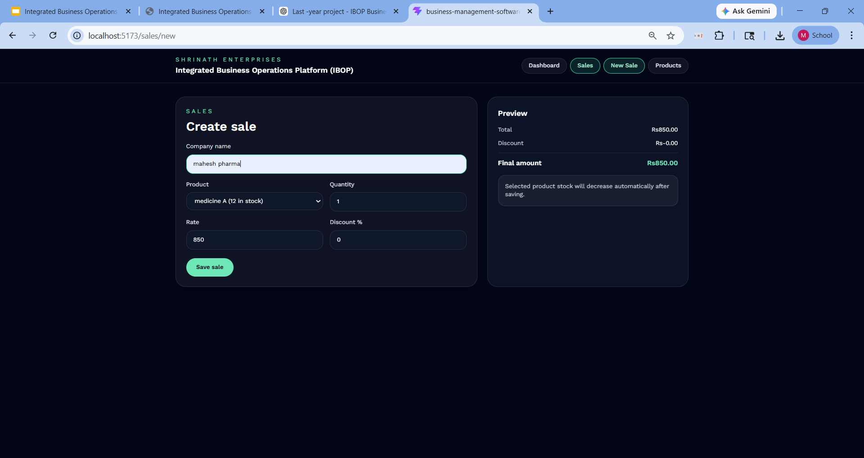
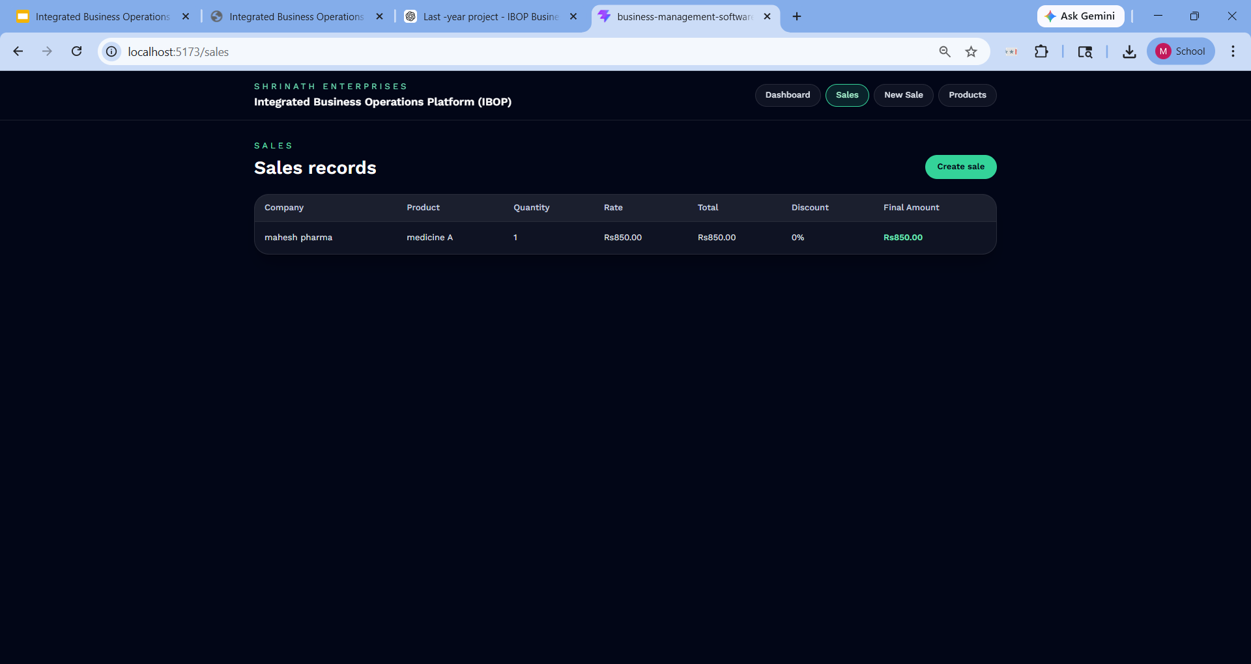
Business Logic Integration
The core functionality of IBOP lies in the integration between the Sales and Inventory modules. The system ensures that business rules are enforced through a dedicated logic layer.
Before processing a sale, the system validates user inputs and checks whether sufficient stock is available. If the stock is insufficient, the transaction is prevented and an appropriate error message is displayed.
Once a valid sale is processed, the system automatically reduces the corresponding product’s stock in the inventory. This ensures data consistency and eliminates manual intervention.

User Interface and Navigation
The user interface is designed to be simple, intuitive, and responsive. A dashboard-based layout is implemented, allowing users to navigate between different modules such as Sales and Inventory.
Navigation is handled using React Router, enabling seamless transitions between pages without reloading the application. Tailwind CSS is used to create a clean and modern interface, ensuring a consistent user experience across all modules.

System Integration and Workflow
The overall workflow of the system begins with user interaction through the dashboard. Users can manage products in the inventory module or create sales in the sales module.
When a sale is recorded, the system processes the input, performs validation, calculates the required values, and updates the inventory accordingly. The updated data is then reflected across the application through the centralized state management system.
This integrated workflow ensures efficient data handling, reduces redundancy, and improves operational accuracy.

Conclusion
In this project, I designed and developed a functional prototype of an Integrated Business Operations Platform (IBOP) that consolidates key business processes such as sales and inventory into a single system. The platform implements a modular ERP-like structure, allowing different components to interact seamlessly while maintaining a clean and scalable architecture.
I developed core functionalities including product management, sales creation, automatic stock updates, and real-time calculations for transactions. The system ensures data consistency by linking sales directly with inventory, reducing manual intervention and minimizing errors.
The application was built using modern frontend technologies with a focus on simplicity, usability, and real-world applicability. Features such as centralized state management, role-based workflow design, and a modular dashboard demonstrate how business operations can be digitized effectively.
Overall, this project showcases my ability to design and implement a practical, scalable system that can be extended into a full-fledged ERP solution for real-world business environments.

